Gametogenesis – Notes
- The process that creates the male (spermatozoa) and female (ovum) gametes.
- Gametes have the haploid (n) number of chromosomes.
- The ovum and spermatozoa join during fertilisation to form a zygote (2n).
- Spermatogenesis is the formation of a spermatozoa in the seminiferous tubules of the testes.
- Oogenesis is the formation of ova in the ovary.

Spermatogenesis – Notes
- Occurs inside the seminiferous tubules of each testis.
- The seminiferous tubules are lined with immature cells called spermatogonia (sperm mother cells (2n)).
- Spermatogonia (sperm mother cells (2n)) undergo mitosis at puberty (under the influence of follicle stimulating hormone (FSH)) so that there’s a constant source of cells for sperm production.
- Primary spermatocytes (2n) are daughter cells from the spermatogonia that move to the centre of the seminiferous tubule and grow.
- Secondary spermatocytes (n) are primary spermatocytes that undergo Meiosis I and become haploid. 2 haploid secondary spermatocyte cells arise from one primary spermatocyte cell.
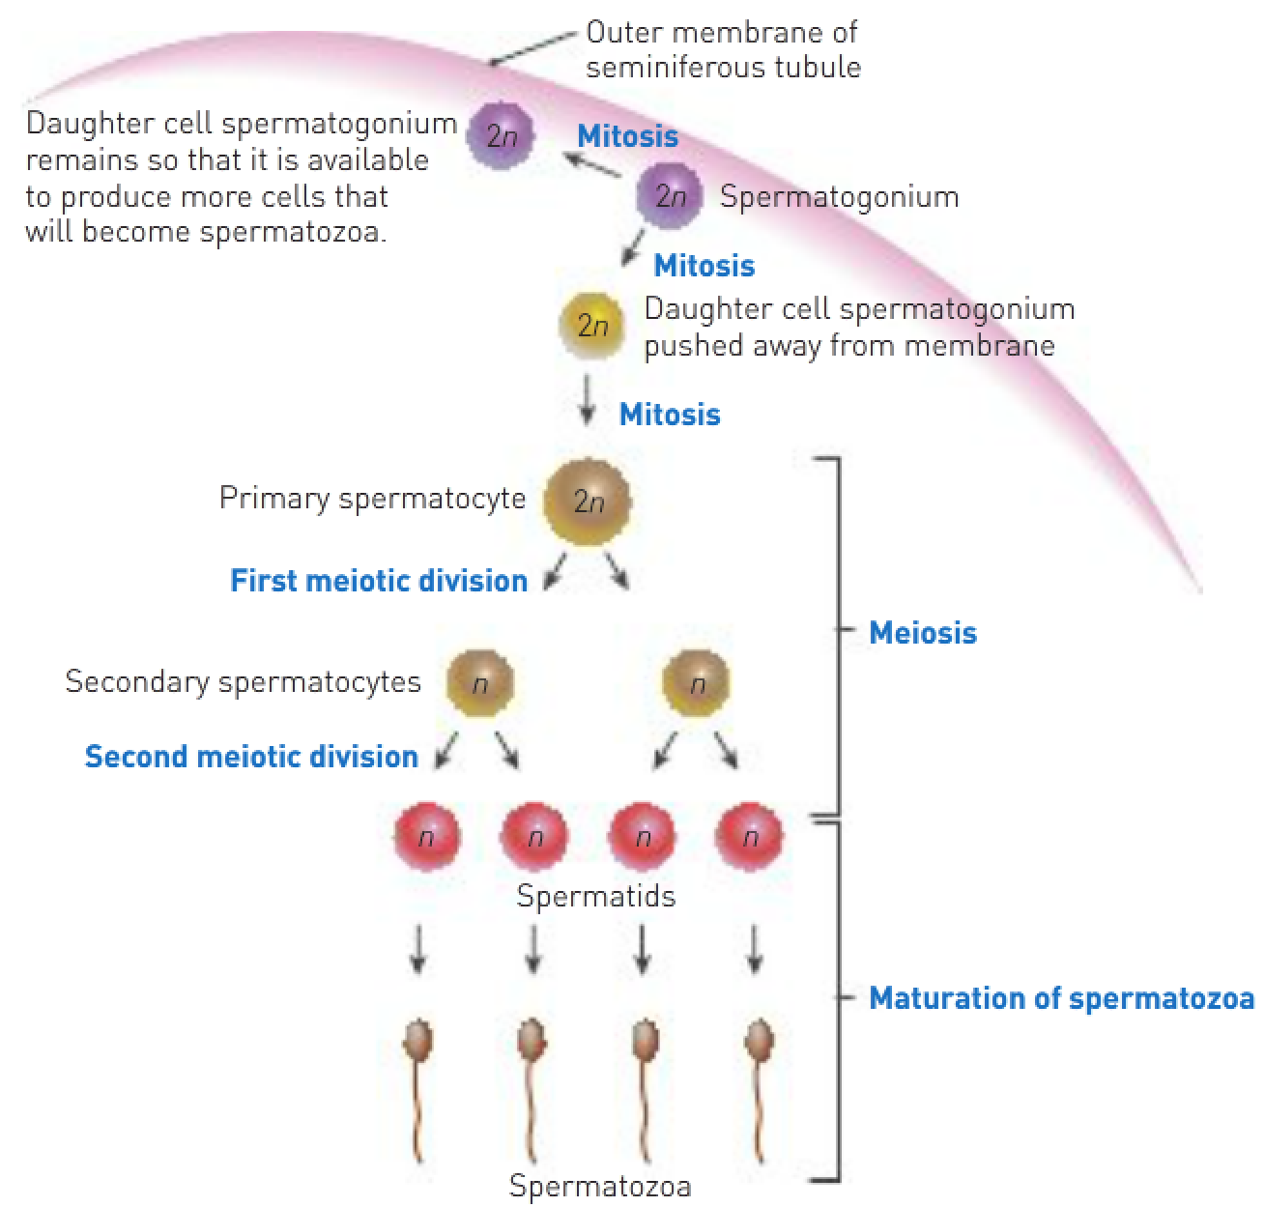
- Each secondary spermatocyte undergoes Meiosis II and becomes 2 spermatids (n).
- There are now 4 haploid spermatids (2 from each secondary spermatocyte) from one diploid spermatogonium.
- Finally, the spermatids mature to be spermatozoa (sperm). They lose their cytoplasm and form a tail containing contractile material.
- The maturing spermatozoa are nourished during this stage by special cells that extend from the outer portion of the seminiferous tubule into the centre.
- Spermatogenesis takes 72 days.

Spermatozoa:
- Have a head, neck, middle piece and tail.
- The head consists of DNA and a fluid-filled vesicle at the tip that contains enzymes to break down the acid on the outside of an ovum.
- The tail is necessary to allow motility (movement) of the sperm.
- The middle piece contains large numbers of mitochondria for cellular respiration to provide energy for movement. Seminal vesicle secretions need to provide energy because the middle piece is surrounded by only a small amount of cytoplasm.
- Because there’s so little cytoplasm, sperm have a short survival period and receive their nourishment from the semen in which they’re suspended.
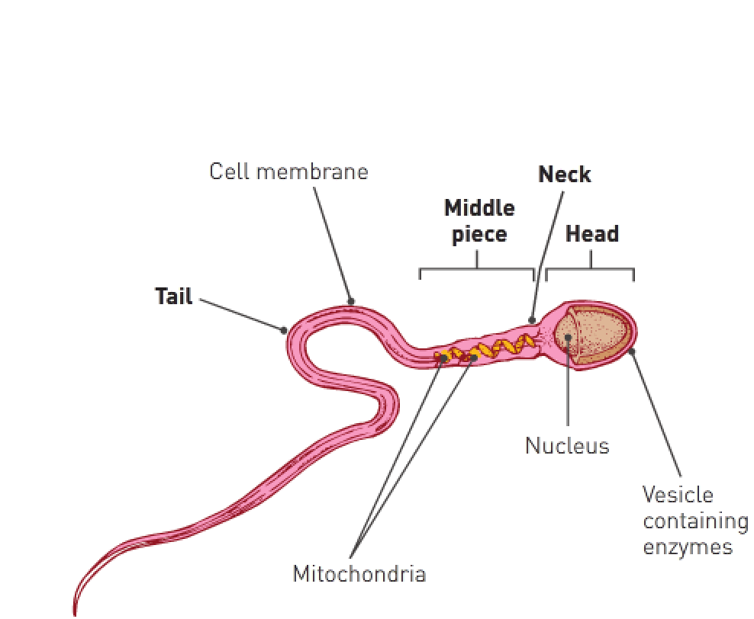
Oogenesis – Notes
- The production of ova within the ovary.
- Oogonia (2n(44+XX)) are diploid mother cells that eventually become ova.
- There are millions of oogonia in the female ovaries prior to the female foetus being born. They’ve been undergoing mitosis up to this point to become primary oocytes (2n(44+XX)).
- Primary oocytes have undergone Prophase I and stopped at that point; at birth they’re still at Prophase I. Each primary oocyte is surrounded by a primary follicle.
- At puberty, under the influence of FSH, the primary oocyte and follicle begin to mature and grow.
- As it matures, the primary oocyte finishes Meiosis I to form 2 haploid cells.
- Of the 2 haploid cells, one receives most of the cytoplasm and is called the secondary oocyte.
- The other receives little cytoplasm and is called the first polar body. They both receive 23 chromosomes (22+X).
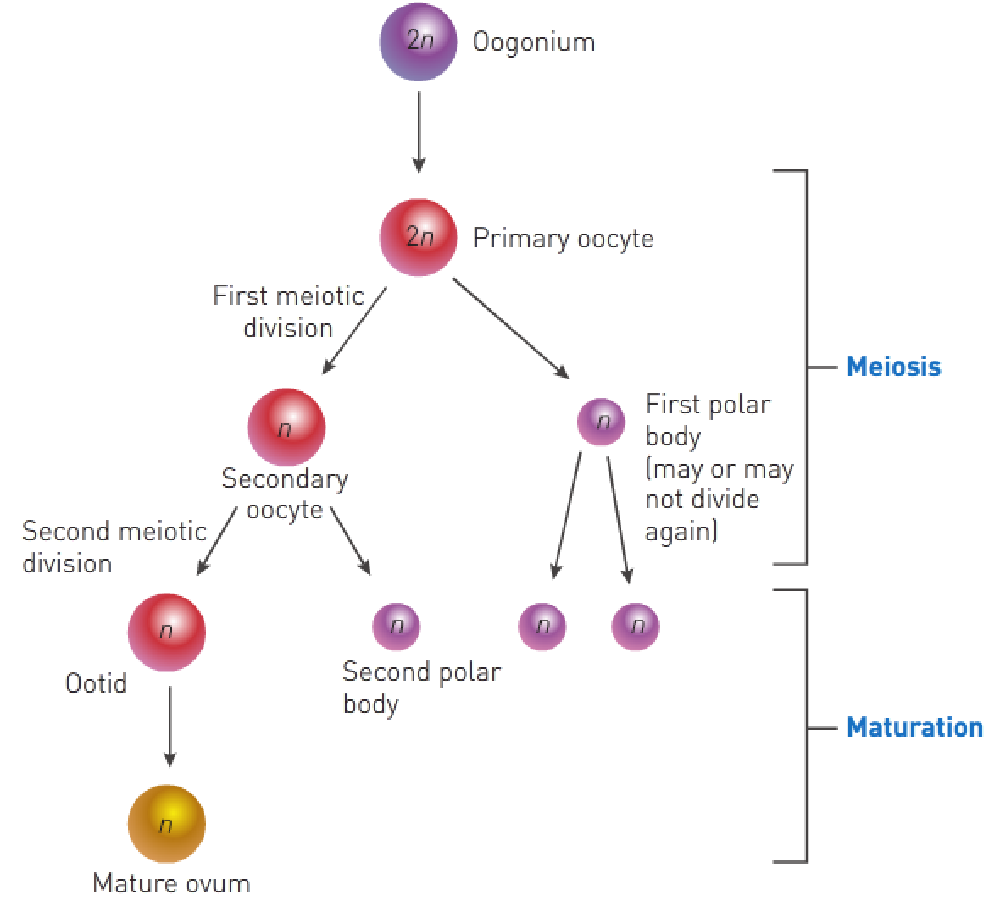
- The secondary oocyte starts Meiosis II but stops at Metaphase II until ovulation.
- At this stage ovulation occurs; the follicle ruptures, expelling the secondary oocyte and, if penetrated by a spermatozoon, meiosis is quickly completed.
- If expelled by ovulation, the secondary follicle ruptures and the secondary oocyte with the first polar body moves from the ovary into the oviduct. If fertilised, the secondary oocyte completes Meiosis II rapidly.
- If not expelled via ovulation, the secondary oocyte and first polar body can go through Meiosis II.
- This forms an ootid (nearly matured ovum (n)) and second polar body from the secondary oocyte and 2 polar bodies from the first polar body.
- The ootid (n) can become a mature ovum.
- All polar bodies disintegrate.
- One mature ovum and 3 polar bodies can be formed from one primary oocyte.

